SI3PSI – Team Terminal

DATABASE SPECIFICATION
FOR GoldenView PROJECT

Version V 1.0
Date: 19. 04.2023.

Revision history

Revision | Datum | Author | Description
VersionV 1.0 | 19.04.2023. | Jovan Jovanovic  Jovana Bjelica

Content
1. Introduction 5
1.1 Purpose 5
1.2 Target groups 5
1.3 Document organization 5
1.4 Glossary of terms and abbreviations 5
1.5 Open questions 5
2. Database model 6
2.1 IE notation diagram 6
2.2 Relation database schema 6
3. Tabels 8
3.1 User 8
3.2 UsersGroup 8
3.3 Role 8
3.4 HasRole 8
3.5 PasswordChangeRequest 8
3.6 Administrator 9
3.7 Trader 9
3.8 BasicUser 9
3.9 Broker 9
3.10 BrokerRequest 9
3.11 TextFile 10
3.12 BrokerRequestFile 10
3.13 ApprovalReportFile 10
3.14 BrokerBasicUserContractFile 10
3.15 BrokerBasicUserContract 10
3.16 Country 11
3.17 FundsTransferMethod 11
3.18 MakeBeliefOwns 11
3.19 Asset 11
3.20 ActiveTradeRequest 11
3.21 PurchaseRequest 12
3.22 SalesRequest 12
3.23 IsBindedByContract 12
3.24 Asset_stats 12
3.25 Carried_out_trade_request 13
3.26 Asset_transaction 13
3.27 Contact_support_request 14

1. Introduction

1.1 Purpose

The database for the project from the course Principles of Software Engineering is a flexible and reliable way of storing data and accessing it by a web server to generate web pages.
The document includes a diagram (data model) with IE (Information Engineering) notation, a scheme of the relational database, as well as a description of all the tables in the database.
This document serves as the basis for the development of the detailed design specification of the observed subsystem, implementation and testing. All data that needs to be stored is obtained in the phase of analyzing user requests.

1.2 Target groups
The document is intended for the team leader of the project and members of the development team.
This document serves the team leader to plan development activities and specify table names and field names in the database, so that independent units, implemented by different parts of the development team, are successfully integrated at the end of the work.
The development team uses the document as a basis for design and implementation.

1.3 Document organization
The rest of the document is organized into the following chapters:
- Data model - database model and database schema;
- Tabels;

1.4 Glossary of terms and abbreviations

- IE – Information Engineering, database modeling notation;

1.5 Open questions

Number | Date | Problem | Solution

2. Database model

2.1 IE notation diagram

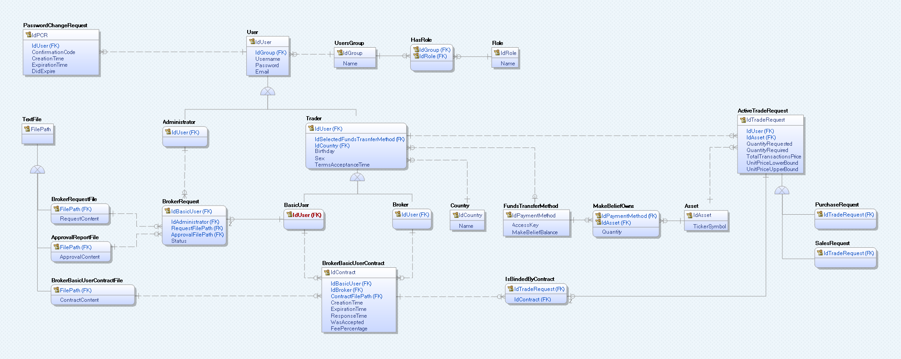

2.2 Relation database schema

User (IdUser, IdGroup, Username, Password, Email)
UsersGroup (IdGroup, Name)
Role (IdRole, Name)
HasRole (IdGroup, IdRole)
PasswordChangeRequest (IdPCR, IdUser, ConfirmationCode, CreationTime, ExpirationTime, DidExpire)
Administrator (IdUser)
Trader (IdUser, IdSelectedFundsTransferMethod, IdCountry, Birthday, Sex, TermsAcceptanceTime)
BasicUser (IdUser)
Broker (IdUser)
BrokerRequest (IdBasicUser, IdAdministrator, RequestFilePath, ApprovalFilePath, Status)
TextFile (FilePath)
BrokerRequestFile (FilePath, RequestContent)
ApprovalReportFile (FilePath, ApprovalContent)
BrokerBasicUserContractFile (FilePath, CotnractContent)
BrokerBasicUserContract (IdContract, IdBasicUser, IdBroker, ContractFilePath, CreationTime, ExpirationTime, ResponseTime, WasAccepted, FeePercentage)
Country (IdCountry, Name)
FundsTransferMethod (IdPaymentMethod, AccessKey, MakeBeliefBalance)
MakeBeliefOwns (IdPaymentMethod, IdAsset, Quantity)
Asset (IdAsset, TickerSymbol)
ActiveTradeRequest (IdTradeRequest, IdUser, IdAsset, QuantityRequested, QuantityRequired, TotalTransactionsPrice, UnitPriceLowerBound, UnitPriceUpperBound)
PurchaseRequest (IdTradeRequest)
SalesRequest (IdTradeRequest)
IsBindedByContract (IdTradeRequest, IdContract)

3. Tabels

3.1 User
Contains information about users of the application.

Name | Datatype | Is PK | Is FK
IdUser | Integer | Yes | No
IdGroup | Integer | No | Yes
Username | Varchar(32) | No | No
Password | Varchar(32) | No | No
Email | Varchar(64) | No | No

3.2 UsersGroup
Contains information about user groups in the application.

Name | Datatype | Is PK | Is FK
IdGroup | Integer | Yes | No
Name | Varchar(18) | No | No

3.3 Role
Contains information about roles in the application.

Name | Datatype | Is PK | Is FK
IdRole | Integer | Yes | No
Name | Varchar(18) | No | No

HasRole
Contains ordered pairs of user groups and roles assigned to them.

Name | Datatype | Is PK | Is FK
IdGroup | Integer | Yes | Yes
IdRole | integer | Yes | Yes

PasswordChangeRequest
The table tracks all changes to the passwords of user accounts of the application, when and which confirmation code was sent, until when it was valid and whether it has expired, i.e. whether the code has been changed.

Name | Datatype | Is PK | Is FK
IdPCR | Integer | Yes | No
IdUser | Integer | No | Yes
ConfirmationCode | Smallint | No | No
CreationTime | Date | No | No
ExpirationTime | Date | No | No
DidExpire | Boolean | No | No

Administrator
Contains information about administrators in the application.

Name | Datatype | Is PK | Is FK
IdUser | Integer | Yes | yes

Trader
Contains information about traders in the application.

Name | Datatype | Is PK | Is FK
IdUser | Integer | Yes | Yes
IdSelectedFundsTransferMethod | Integer | No | Yes
IdCountry | Integer | No | Yes
Birthday | Date | No | No
Sex | Varchar(6) | No | No
TermsAcceptanceTime | Date | No | No

BasicUser
Contains information about basic users in the application.

Name | Datatype | Is PK | Is FK
IdUser | Integer | Yes | Yes

Broker
Contains information about brokers in the application.

Name | Datatype | Is PK | Is FK
IdUser | Integer | Yes | Yes

BrokerRequest
It contains information about users who submitted a request to become a Broker, which of the administrators reviewed the request, by which path the request was sent, by which path the request was received and the status of the request (rejected/accepted).

Name | Datatype | Is PK | Is FK
IdBasicUser | Integer | Yes | Yes
IdAdministrator | Integer | Yes | Yes
RequestFilePath | Varchar(128) | No | Yes
ApprovalFilePath | Varchar(128) | No | Yes
Status | Varchar(16) | No | No

3.11 TextFile
Contains the paths of all files stored on the system.

Name | Datatype | Is PK | Is FK
FilePath | Varchar(128) | Yes | No

3.12 BrokerRequestFile
Contains the file paths of the user's request to become a broker.

Name | Datatype | Is PK | Is FK
FilePath | Varchar(128) | Yes | Yes
RequestContent | Varchar(256) | No | No

3.13 ApprovalReportFile
Contains file paths of responses to user requests to become brokers.

Name | Datatype | Is PK | Is FK
FilePath | Varchar(128) | Yes | Yes
ApprovalContent | Varchar(256) | No | No

3.14 BrokerBasicUserContractFile
Contains the paths of the files that will be part of the contract.

Name | Datatype | Is PK | Is FK
FilePath | Varchar(128) | Yes | Yes
CotnractContent | Varchar(256) | No | No

3.15 BrokerBasicUserContract
Contains data on contracts of ordinary users and brokers.

Name | Datatype | Is PK | Is FK
IdContract | Integer | Yes | No
IdBasicUser | Integer | No | Yes
IdBroker | Integer | No | Yes
ContractFilePath | Varchar(128) | No | Yes
CreationTime | Date | No | No
ExpirationTime | Date | No | No
ResponseTime | Date | No | No
WasAccepted | Boolean | No | No
FeePercentage | Float | No | No

3.16 Country
Contains information about countries in the application.

Name | Datatype | Is PK | Is FK
IdCountry | Integer | Yes | No
Name | Varchar(32) | No | No

3.17 FundsTransferMethod
Contains information about virtual vaults in the application owned by a trader.

Name | Datatype | Is PK | Is FK
IdPaymentMethod | Integer | Yes | No
AccessKey | Varchar(64) | No | No
MakeBeliefBalance | Decimal(10,2) | No | No

3.18 MakeBeliefOwns
Contains data on vaults, which assets contain and in what amount.

Name | Datatype | Is PK | Is FK
IdPaymentMethod | Integer | Yes | Yes
IdAsset | Integer | Yes | Yes
Quantity | Integer | No | No

3.19 Asset
Contains information about assets in the application.

Name | Datatype | Is PK | Is FK
IdAsset | Integer | Yes | No
TicketSymbol | Varchar(16) | No | No

3.20 ActiveTradeRequest
Contains data about all active pending TradeRequests, when they are completed, they are deleted from this table and permanently logged.

Name | Datatype | Is PK | Is FK
IdTradeRequest | Long | Yes | No
IdUser | Integer | No | Yes
IdAsset | Integer | No | Yes
QuantityRequested | Integer | No | No
QuantityRequired | Integer | No | No
TotalTransactionPrice | Decimal(10,2) | No | No
UnitPriceLowerBound | Decimal(10,2) | No | No
UnitPriceUpperBound | Decimal(10,2) | No | No

3.21 PurchaseRequest
Contains TradeRequest data of Purchase type.

Name | Datatype | Is PK | Is FK
IdTradeRequest | Long | Yes | Yes

3.22 SalesRequest
Contains TradeRequest data of a Sales type.

Name | Datatype | Is PK | Is FK
IdTradeRequest | Long | Yes | Yes

3.23 IsBindedByContract
Contains data about active TradeRequests that are related to a contract.

Name | Datatype | Is PK | Is FK
IdTradeRequest | Long | Yes | Yes
IdContract | Integer | No | Yes

3.24 Asset_stats
Contains additional asset data, a dynamic array that will predict asset prices.
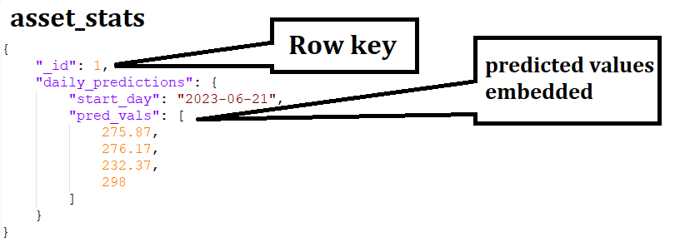

3.25 Carried_out_trade_request
It contains all the transactions that have ever been made.

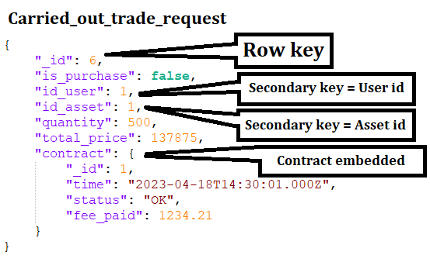

3.26 Asset_transaction
It contains data about transactions that are Asset type, id_trade_request will point to the id of trade_requests that is in the ActiveTradeRequest table, and when the transaction is done, the key points to the row in the table carried_out_trade_request.

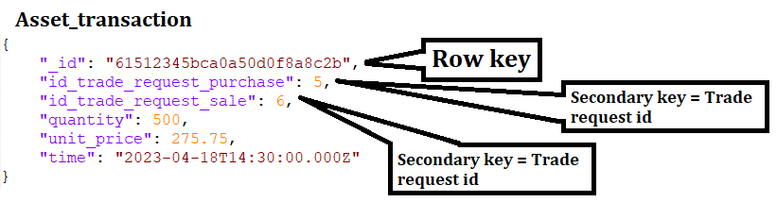

3.27 Contact_support_request
Contains data from customer support messages.
